FARM MANAGEMENT SYSTEM

User Story:
As a farmer, field coordinator, or administrator, I want to manage farm activities through a centralized Salesforce application so that information about land, cultivation, farmers, and customers can be maintained in an organized manner. The application should allow authorized users to create and update records, connect related information, and obtain useful summaries through reports and dashboards. Data validation should reduce incomplete entries, while profiles, roles, and sharing settings should control access. The system is intended to make routine agricultural administration easier, improve record traceability, and provide timely information for planning farm activities.

1. INTRODUCTION

1.1 Project Overview :
The Farm Management System (FMS) is a cloud-based Salesforce application created to organize important agricultural records. It provides a common workspace for maintaining farm information, crop details, farmer profiles, and buyer records. The application also uses Salesforce reporting and dashboard capabilities to convert stored records into operational summaries.

1.2 Purpose :
The main purpose of this project is to:
- Create a common digital repository for farm information
- Simplify the maintenance of crop and stakeholder records
- Improve consistency through structured fields and validation
- Make operational information easier to retrieve
- Support management review using reports and dashboards
- Protect records through controlled user access

2. IDEATION PHASE

2.1 Problem Statement (Customer Problem Statement Template)
PS | I am (Customer) | I’m trying to | But | Because | Which makes me feel
PS-1 | Farm Owner | Maintain updated land and cultivation information | Old records are difficult to trace | Information is stored in separate notebooks | Unsure about the latest details
PS-2 | Field Coordinator | Follow crop progress | Daily information is not consolidated | Updates are received from different sources | Time-consuming and delayed
PS-3 | Buyer | Identify available agricultural products | Product details may not be current | There is no common information repository | Uncertain during purchase planning
PS-4 | Administrator | Manage access for different users | Users may require different permissions | Access settings are configured separately | Responsible for data security

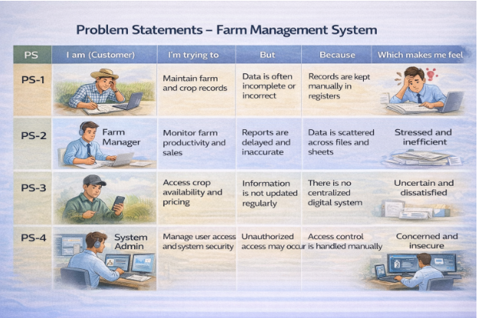2.2 Empathy Map Canvas
Target Users:
- Farm Owners
- Field Coordinators
- Buyers
- System Administrators
Empathy Analysis
- Think & Feel: Want dependable records that can be checked quickly.
- Hear: Requirements from field workers and customers.
- See: Registers, worksheets, messages, and individual files.
- Say & Do: Record farm activities and communicate updates.
- Pain: Repeated work, missing details, and delayed summaries.
- Gain: Organized records, quick retrieval, and better visibility.
- 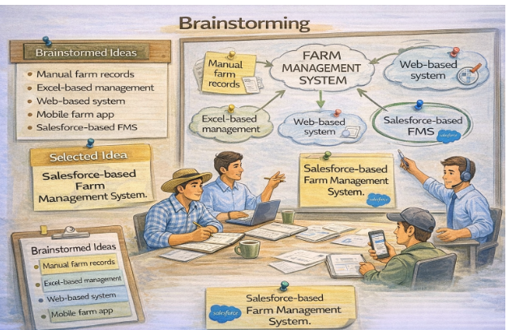

2.3 Brainstorming
Brainstormed Ideas
- Paper-based farm register
- Spreadsheet tracking
- Standalone web portal
- Mobile agriculture tracker
- Salesforce-based Farm Management System
Selected Idea
Salesforce-based Farm Management System.
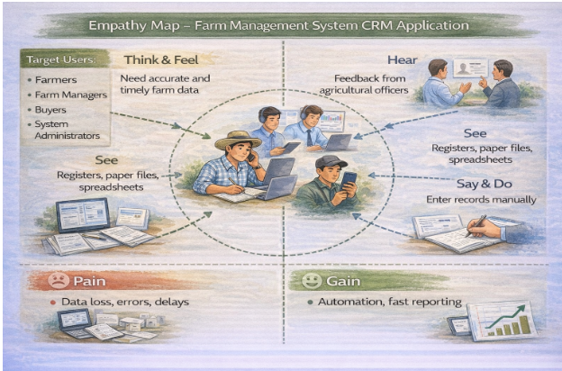

3.REQUIREMENT ANALYSIS PHASE

3.1 Customer Journey Map
1. User signs in to the platform
2. Opens the Farm Management System application
3. Checks or creates farm records
4. Adds crop and farmer information
5. Maintains buyer details
6. Produces reports for review
7. Opens dashboards and reviews indicators
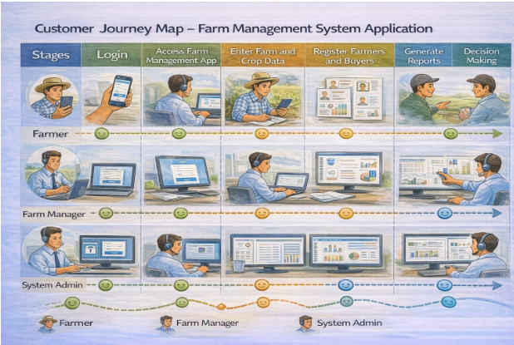

3.2 Solution Requirements

Functional Requirements
FR No | Requirement
FR-1 | User authentication and access control
FR-2 | Create, view, edit, and maintain core farm records
FR-3 | Field validation and mandatory data checks
FR-4 | Connections between related objects
FR-5 | Custom operational reports
FR-6 | Summary dashboards
FR-7 | Role, profile, and sharing configuration

Non-Functional Requirements
NFR | Description | Example
Usability | Users should understand the navigation easily | Lightning navigation
Security | Information should be visible only to authorized users | Profiles and sharing
Reliability | Saved records should remain available | Cloud data storage
Performance | Normal actions should respond without unnecessary delay | Efficient configuration
Availability | Users should be able to access the application when required | Salesforce cloud
Scalability | The design should accommodate additional records and users | Expandable data model

3.3 Data Flow Diagram
User → Login → Farm Management Application → Farm/Crop/Farmer/Buyer Records → Validation & Relationships → Reports → Dashboards → Operational Review
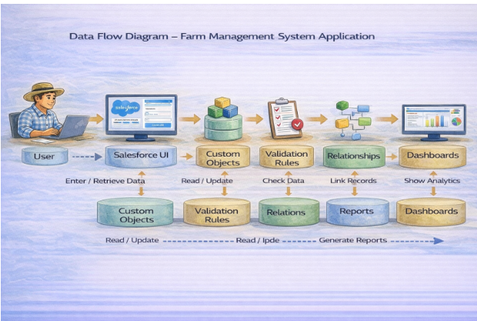

3.4 Technology Stack
Layer | Technology
Presentation | Salesforce Lightning UI
Application | Salesforce Platform
Database | Salesforce Cloud Storage
Data Controls | Validation Rules, Lookup and Master-Detail Relationships
Analytics | Salesforce Reports and Dashboards

4. PROJECT DESIGN PHASE

4.1 Problem–Solution Fit
The proposed application converts scattered agricultural records into a structured Salesforce data model. Instead of maintaining separate lists, users can work with related records from one application. Validation helps maintain data quality, access controls support secure collaboration, and reporting features make stored information easier to review.
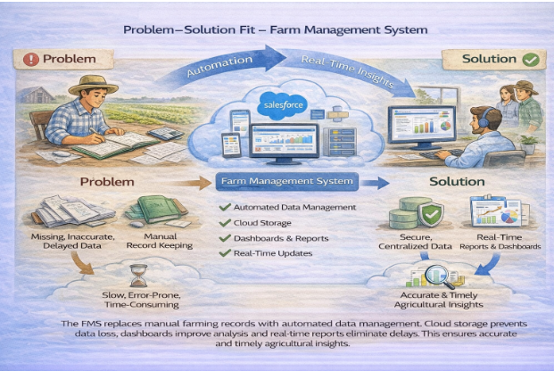

4.2 Proposed Solution
Parameter | Description
Problem | Farm information is maintained through disconnected records, which can make updates and follow-up difficult.
Solution | A centralized Salesforce application for managing agricultural master and transaction information.
Innovation | Connected objects, controlled data entry, configurable access, and visual reporting.
Impact | Improved organization, quicker retrieval, and clearer operational visibility.
Business Model | Cloud-based agricultural record and operational management solution.
Scalability | The configuration can be extended with more users, farms, crops, and analytics.

4.3 Solution Architecture
1. Presentation Layer – Salesforce Lightning pages and navigation
2. Application Layer – Validation, relationships, profiles and sharing
3. Data Layer – Farm, Crop, Farmer and Buyer objects
4. Analytics Layer – Reports and dashboard components
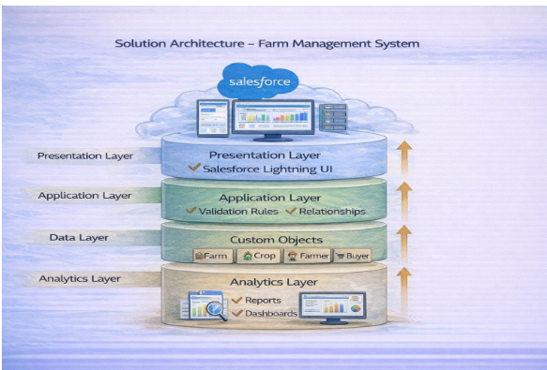

5. PROJECT PLANNING & SCHEDULING

5.1 Project Planning
- Create and configure the Salesforce development environment
- Plan the custom object structure
- Build application tabs and navigation
- Add fields and define relationships
- Configure user profiles and roles
- Set up sharing rules and sample users
- Create reports and dashboard views
- Perform functional testing and review

Product Backlog, Sprint Schedule, and Estimation (4 Marks)
The following backlog distributes the major implementation activities across development sprints.
Sprint | Functional Requirement (Epic) | User Story Number | User Story / Task | Story Points | Priority | Team Members
Sprint-1 | Platform Setup | USN-11 | As an administrator, I want the development environment configured so that the application can be built safely. | 3 | High | Member1
Sprint-2 | Object Design | USN-12 | As a project team, I want the four core objects defined so that agricultural information has a consistent structure. | 5 | High | Member2
Sprint-2 | Navigation | USN-13 | As an application user, I want relevant tabs arranged in one app so that daily navigation is simple. | 3 | Medium | Member3
Sprint-3 | Data Quality | USN-14 | As the system, I want required and restricted values checked so that poor-quality records are minimized. | 3 | High | Member4
Sprint-3 | Relationships | USN-15 | As a manager, I want farm and crop records connected so that related information can be traced. | 3 | High | Member2
Sprint-4 | Access Control | USN-16 | As an administrator, I want differentiated access for operational users so that records are appropriately protected. | 5 | High | Member3
Sprint-5 | Reports | USN-17 | As a coordinator, I want reports for farm and buyer information so that routine review takes less time. | 4 | Medium | Member1
Sprint-6 | Dashboards | USN-18 | As a manager, I want summary components on a dashboard so that important indicators can be viewed together. | 4 | Medium | Member4

Project Tracker, Velocity & Burndown Chart: (4 Marks)
Sprint | Total Story Points | Duration | Sprint Start Date | Sprint End Date (Planned) | Story Points Completed | Sprint Release Date (Actual)
Sprint-1 | 20 | 6 Days | 03 Feb 2026 | 08 Feb 2026 | 19 | 08 Feb 2026
Sprint-2 | 20 | 6 Days | 10 Feb 2026 | 15 Feb 2026 | 20 | 15 Feb 2026
Sprint-3 | 20 | 6 Days | 17 Feb 2026 | 22 Feb 2026 | 18 | 22 Feb 2026
Sprint-4 | 20 | 6 Days | 24 Feb 2026 | 01 Mar 2026 | 20 | 01 Mar 2026

6. Project Development Phase:

Project Description:
The Farm Management System in Salesforce is developed as a configurable application for storing and connecting agricultural information. The four primary modules represent farms, crops, farmers, and buyers. The application combines record management with access controls and analytical views so that different users can work with information appropriate to their responsibilities.

Milestone 1-Salesforce:

What Is Salesforce?
Salesforce is a cloud platform that provides tools for building applications, storing records, managing access, automating processes, and presenting information through reports and dashboards. For this project, Salesforce configuration features are used rather than a separate database application.

Activity1: Creating a Salesforce Developer Org:
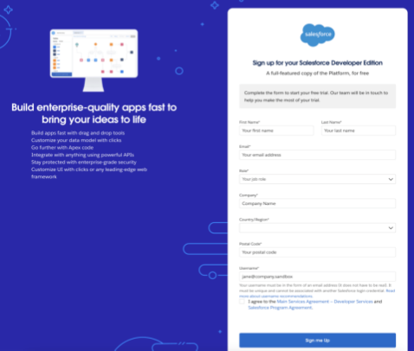
1. Open the Salesforce Developer registration page.
2. Enter the requested personal and account information.
3. Choose a unique username for the development organization.
4. Submit the registration and verify the account through email.
5. Create the password and complete the account setup.
6. Sign in to the Salesforce organization.
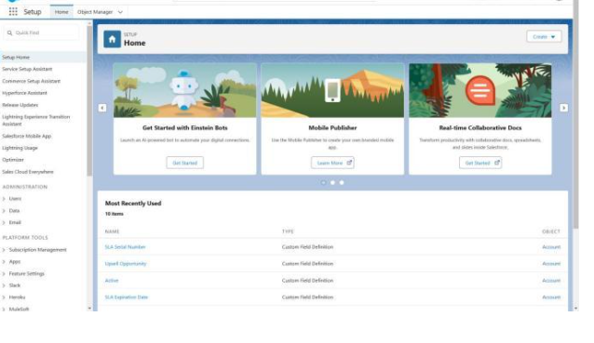

Milestone 2-Object:

What is an object?
A Salesforce object is a structured data container used to store related records. Fields describe individual properties of a record, while relationships connect information stored in different objects.
In This Application We Use 4 Custom Objects:
1. Farm
2. Crop
3. Farmer
4. Buyer

Activity 1: Create a custom object for Farm:
1. From Setup, open Object Manager.
2. Choose Create and select Custom Object.
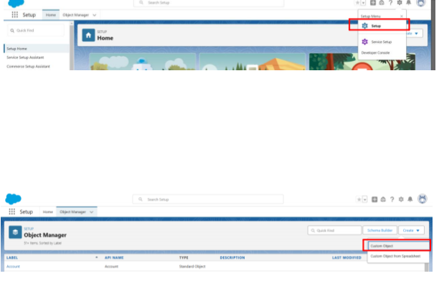
3. Enter Farm as the label and Farms as the plural label.
4. Set Farm Name as the record name and select Text.
5. Enable the required reporting and search options.
6. Configure the page-layout options and save the object.
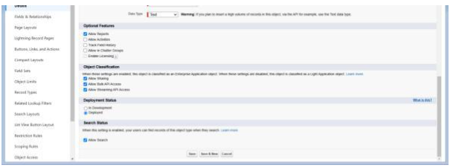

Activity 2: Creation of Crop object:
1. Open Object Manager and choose Create → Custom Object.
2. Set Label to Crop and Plural Label to Crops.
3. Use Crop Name as the text record name.
4. Enable reporting and search.
5. Configure notes/attachments if required by the project layout.
6. Save the object.

Activity 3: Creation of Farmer object:
1. Create a new custom object from Object Manager.
2. Set Label to Farmer and Plural Label to Farmers.
3. Set Farmer Name as a Text record name.
4. Enable reporting and search.
5. Configure the default page layout options and save.

Activity 4: Creation of Buyer object:
1. Create another custom object from Object Manager.
2. Enter Buyer and Buyers as the singular and plural labels.
3. Use Buyer Name as the Text record name.
4. Enable reporting and search.
5. Apply the required page-layout options and save.

Milestone 3 - Tab: Tab
Salesforce tabs provide an entry point for users to open records belonging to a particular object. Separate tabs make the four modules easier to navigate.

Activity: Creation of Farm tab:
1. Open Setup and search for Tabs.
2. Under Custom Object Tabs, choose New.
3. Select the required object.
4. Select a suitable tab style.
5. Continue through the default settings and save.
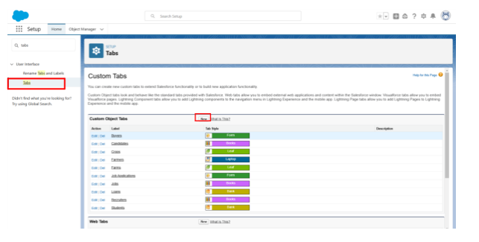

Activity: Creation of Crop tab:
1. Open Setup and search for Tabs.
2. Under Custom Object Tabs, choose New.
3. Select the required object.
4. Select a suitable tab style.
5. Continue through the default settings and save.

Activity: Creation of Farmer tab:
1. Open Setup and search for Tabs.
2. Under Custom Object Tabs, choose New.
3. Select the required object.
4. Select a suitable tab style.
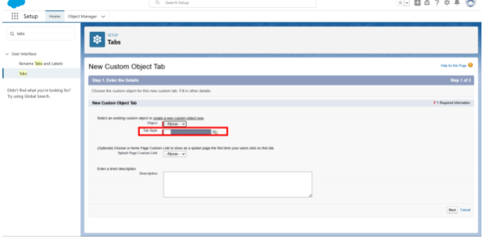
5. Continue through the default settings and save.

Activity: Creation of Buyer tab:
1. Open Setup and search for Tabs.
2. Under Custom Object Tabs, choose New.
3. Select the required object.
4. Select a suitable tab style.
5. Continue through the default settings and save.

Milestone 4 - Lightning App:

What is an App?
A Salesforce app is a collection of related navigation items and features presented as a working environment. The project app brings the farm modules, reports, and dashboards together.

Activity 1: Create the Farm Management System app
1. Open App Manager from Setup.
2. Select New Lightning App.
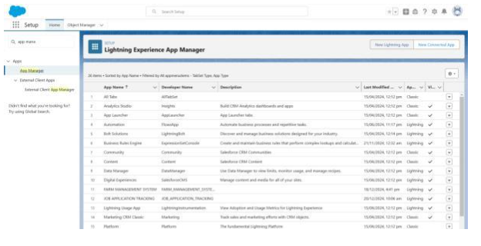
3. Enter Farm Management System as the app name.
4. Review the app options and continue.
5. Add Farm, Crop, Farmer, Buyer, Reports, and Dashboards to the navigation menu.
6. Assign the required profile.
7. Save and finish the application.
8. Open the App Launcher and verify that the application appears.
Note:
1. App Launcher – Provides access to available Salesforce applications.
2. App Name – Identifies the currently selected application.
3. Navigation Menu – Provides access to the tabs included in the app.
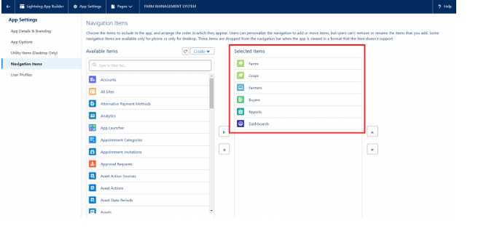

Milestone 5 - Fields and Relationship:

What are fields?
Fields are the individual information units stored within Salesforce records. Choosing suitable field types helps the application capture data consistently and allows users to filter and report on it.

Activity 1: Creation of fields for the Farm objects:
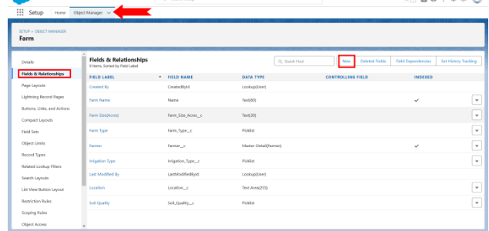
- Farm Category – Picklist: Crop, Dairy, Mixed
- Soil Condition – Picklist: Fertile, Moderate, Needs Improvement
- Water Source – Picklist: Borewell, Canal, Rainwater
- Farm Location – Text
- Cultivated Area – Number
- Farmer – Master-Detail relationship

Activity 2: Creation of fields for the Crop objects:
- Crop Name – Text
- Sowing Date – Date
- Planned Harvest Date – Date
- Farm – Lookup relationship
- Harvest Quantity – Number
- Cultivated Area – Number
- Yield Rate – Formula using harvest quantity and cultivated area

Activity 3: Creation of fields for the Farmer objects:
- Mobile Number – Phone
- State – Picklist
- District – Picklist
- Village – Picklist

Creation of field dependency:
1. Open the Farmer object and go to Fields & Relationships.
2. Select the Field Dependencies option and create a new dependency.
3. Choose State as the controlling field.
4. Choose District as the dependent field.
5. Map the permitted district values to each state.
6. Use Preview to verify the dependency.
7. Save the configuration.

Activity 4: Creation of fields for the Buyer objects:
- Contact Number – Phone
- Email Address – Email
- Delivery Address – Text Area
- Customer Category – Picklist: Wholesale, Retail, Institutional

Milestone 6- Profile:

What is a profile?
A profile is a collection of permissions and settings assigned to Salesforce users. It determines which objects, fields, tabs, and application features a user can access. Each user is assigned one profile.

Activity 1: Create a custom profile:
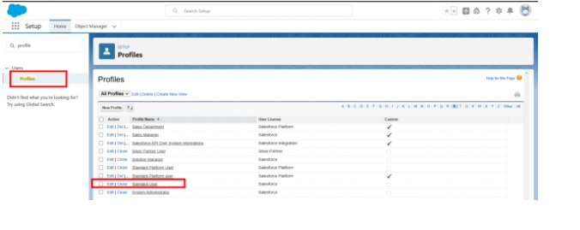
1. Search for Profiles in Setup.
2. Select an appropriate standard profile.
3. Choose Clone.
4. Name the new profile Farm Operations User.
5. Configure the required application and object permissions.
6. Save the profile.

Activity 2: Create a custom profile-2:
1. Clone a suitable standard profile.
2. Enter Farm Coordinator as the profile name.
3. Provide access to the required farm-related objects and reports.
4. Save and review the profile settings.

Milestone 7- Role
Roles help represent the organization's reporting hierarchy and can affect record visibility. They provide a structure in which users can be placed according to their responsibilities.

Activity-1: Creation of role
1. Search for Roles in Setup.
2. Open the role hierarchy configuration.
3. Select the appropriate parent position.
4. Add a new role named Farm Coordinator.
5. Save the role and confirm its position in the hierarchy.
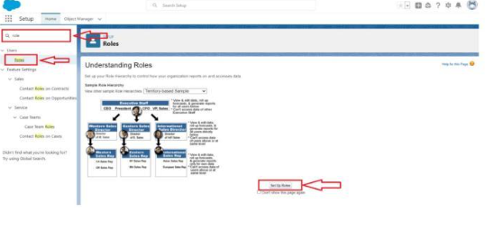

Milestone 8-User:

What is a user?
A user is an account that can access Salesforce. User settings combine login information, license, profile, role, and other permissions to determine how the person interacts with the application.
NOTE- The number of active users and available licenses depends on the Salesforce organization and license configuration. If a development environment reaches its license limit, an unused user may need to be deactivated or reassigned according to the available options.

Activity 1:
1. From Setup, search for Users and select Users.
2. Click New User.
3. Enter the user's first name, last name, email, and unique username.
4. Assign the Farm Coordinator role.
5. Select the available license.
6. Assign the Farm Coordinator profile
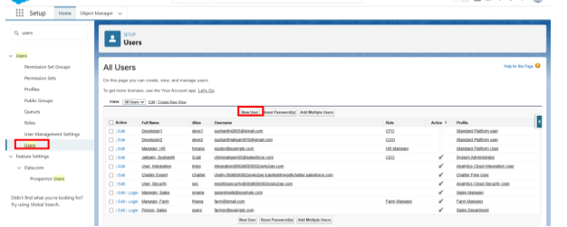.
7. Save the user.

Activity 2:
Create another application user for buyer coordination. Assign the appropriate license, profile, and role and then verify the user's access.

Milestone 9-Sharing Rules:

What are Sharing Rules?
Sharing rules provide additional record access when the organization's default access settings do not give a user enough visibility. They can be created using ownership or criteria and are intended to extend access.
Types of sharing rules:
- Owner-based Sharing Rules
- Criteria-based Sharing Rules

Activity 1:
1. Open Sharing Settings from Setup.
2. Locate the object that requires additional access.
3. Select New Sharing Rule.
4. Enter a meaningful label.
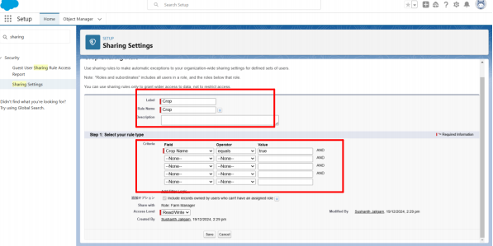
5. Choose the appropriate sharing rule type.
6. Define the ownership or criteria condition.
7. Select the Farm Coordinator role or other authorized group.
8. Select the required access level.
9. Save the rule.

Activity 2:
Create a sharing rule that allows the buyer coordination role to work with Buyer records. Configure the criteria and Read/Write access according to the project requirement.

Milestone-10: User Adoption

Activity 1:Create a Record(Farmer)
1. Open the App Launcher.
2. Search for Farm Management System and launch it.
3. Select the Farmer tab.
4. Click New.
5. Enter valid farmer information.
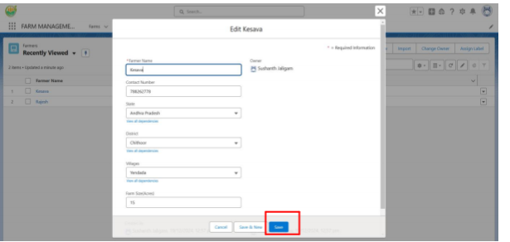
6. Save the record.
7. Reopen the record to confirm that the information was stored correctly.

Milestone 11-Reports:

What are Reports?
A Salesforce report is a configurable view of records that match selected conditions. Reports can include columns, filters, groupings, summaries, and charts and can be stored in shared or restricted folders.

Activity 1:
1. Open the Reports tab.
2. Select New Report.
3. Choose a report type related to Farmers and Farms.
4. Add the fields required for the report.
5. Apply filters and grouping.
6. Preview the result.
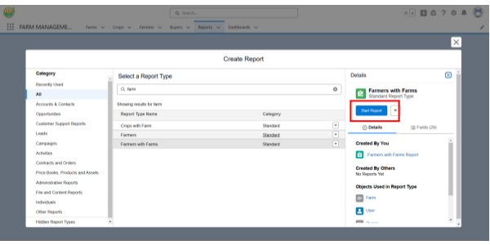
7. Save the report with an appropriate name and folder.

Activity 2:
Create a second report using Crop and Buyer information. Include the fields needed to review crop records and customer activity, then save the report for authorized users.

Milestone 12-Dashboard:
A dashboard presents information from one or more reports through visual components. It can provide a compact view of operational information such as record counts, categories, and activity summaries.

Activity 1:
1. Open the Dashboard tab.
2. Select New Dashboard.
3. Name the dashboard Farm Operations Summary.
4. Add a component based on a suitable report.
5. Select an appropriate chart or table type.
6. Add additional components if needed.
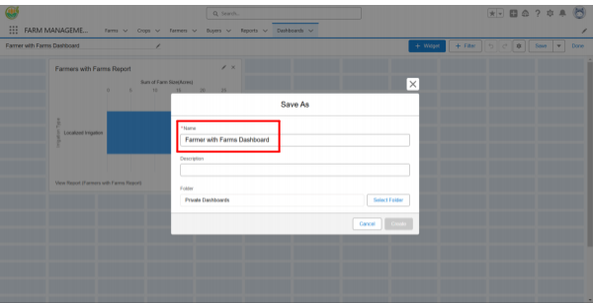
7. Save and complete the dashboard.

Milestone-13: View Report and Dashboard:

Activity 1: Report
1. Open the Farm Management System app.
2. Select Reports.
3. Choose the required saved report.
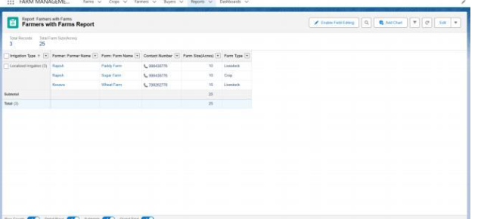
4. Review the displayed records and summaries.

Activity 2: Dashboard
1. Open the Dashboard tab.
2. Select Farm Operations Summary.
3. Review the visual components.
4. Check that the dashboard reflects the underlying report data.
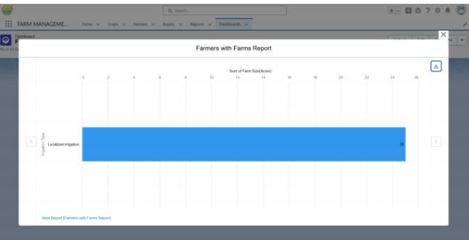

7. FUNCTIONAL & PERFORMANCE TESTING
The testing phase verifies whether the configured application behaves according to the project requirements. Test cases should cover record creation, data quality, relationships, security, reports, and dashboards.
- Farm, Crop, Farmer, and Buyer record creation and editing
- Required-field and value validation
- Lookup and master-detail relationship checks
- State and district dependency verification
- Profile and role permission checks
- Sharing-rule access checks
- Report filter and grouping verification
- Dashboard component verification
- Basic response and stability checks

8. ADVANTAGES & DISADVANTAGES

Advantages
- Centralized agricultural information
- Reduced dependence on handwritten registers
- Consistent field-based data entry
- Improved relationship tracking between records
- Easy creation of management summaries
- Controlled access for different user groups

Disadvantages
- Cloud access normally depends on internet connectivity
- Salesforce platform and license limits may apply
- Users need initial training
- Offline workflows require additional implementation

9. Conclusion:
The Farm Management System demonstrates how Salesforce can be configured to organize agricultural records in a single application. The project combines custom objects, fields, relationships, profiles, roles, sharing rules, reports, and dashboards. This structure provides a practical foundation for maintaining farm information and reviewing operational data in a consistent manner.

10. FUTURE SCOPE
- Add a mobile-friendly field data entry solution
- Connect local weather and rainfall services
- Introduce crop yield analytics
- Integrate sensor data from irrigation and soil devices
- Add alerts for important farm activities
- Connect market information services
- Support additional agricultural modules such as inventory and equipment tracking

11. APPENDIX
- Application Configuration: Salesforce custom objects, fields, relationships, profiles, roles, sharing rules, reports, and dashboards
- Sample Data: Farm, Crop, Farmer, and Buyer records
- Development Environment: Salesforce Developer Organization
- Testing Evidence: Functional and access-control verification

Thank You

